Activity_Main.xml

<?xml version="1.0" encoding="utf-8"?>

<LinearLayout xmlns:android="http://schemas.android.com/apk/res/android"

xmlns:app="http://schemas.android.com/apk/res-auto"

xmlns:tools="http://schemas.android.com/tools"

android:layout_width="match_parent"

android:layout_height="match_parent"

android:orientation="vertical"

tools:context=".MainActivity">

<TextView

android:layout_width="match_parent"

android:layout_height="wrap_content"

android:text="Rutvik patel!"

android:textSize="30dp"

android:layout_marginTop="150dp"

android:gravity="center"/>

<EditText

android:layout_width="match_parent"

android:layout_height="wrap_content"

android:id="@+id/etname"

android:layout_marginTop="10dp"

android:hint="Enter Your Name"

android:textSize="10dp" />

<Button

android:layout_width="match_parent"

android:layout_height="wrap_content"

android:id="@+id/btclick"

android:gravity="center"

android:hint="SUBMIT"

android:textSize="10dp"

android:layout_marginTop="15dp"/>

</LinearLayout>

MainActivity.java

package com.example.myapplication;

import androidx.appcompat.app.AppCompatActivity;

import android.content.Intent;

import android.os.Bundle;

import android.view.View;

import android.widget.Button;

import android.widget.EditText;

public class MainActivity extends AppCompatActivity {

EditText etname;

Button btclick;

@Override

protected void onCreate(Bundle savedInstanceState) {

super.onCreate(savedInstanceState);

setContentView(R.layout.activity_main);

etname = (EditText) findViewById(R.id.etname);

btclick = (Button) findViewById(R.id.btclick);

btclick.setOnClickListener(new View.OnClickListener() {

@Override

public void onClick(View v) {

String name = etname.getText().toString();

Intent intent = new Intent(MainActivity.this,DisplayActivity.class);

intent.putExtra("NAME", name);

startActivity(intent);

}

});

}

}

Activity_Display.xml

<?xml version="1.0" encoding="utf-8"?>

<LinearLayout xmlns:android="http://schemas.android.com/apk/res/android"

xmlns:app="http://schemas.android.com/apk/res-auto"

xmlns:tools="http://schemas.android.com/tools"

android:layout_width="match_parent"

android:layout_height="match_parent"

tools:context=".DisplayActivity">

<TextView

android:layout_width="match_parent"

android:layout_height="wrap_content"

android:id="@+id/tvname"

android:textSize="20dp"

android:textStyle="bold"/>

</LinearLayout>

DisplayActivity.java

package com.example.myapplication;

import androidx.appcompat.app.AppCompatActivity;

import android.content.Intent;

import android.os.Bundle;

import android.widget.TextView;

public class DisplayActivity extends AppCompatActivity {

TextView tvname;

@Override

protected void onCreate(Bundle savedInstanceState) {

super.onCreate(savedInstanceState);

setContentView(R.layout.activity_display);

tvname = (TextView) findViewById(R.id.tvname);

Intent intent=getIntent();

String name=intent.getStringExtra("NAME");

tvname.setText("WELCOME " +name);

}

}

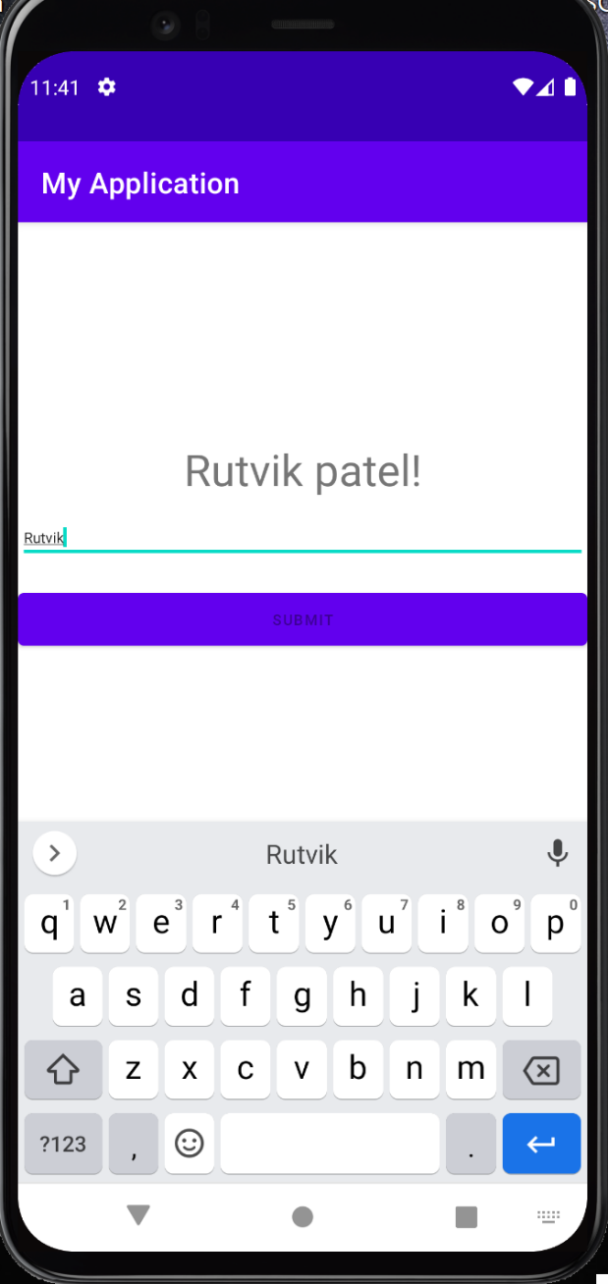 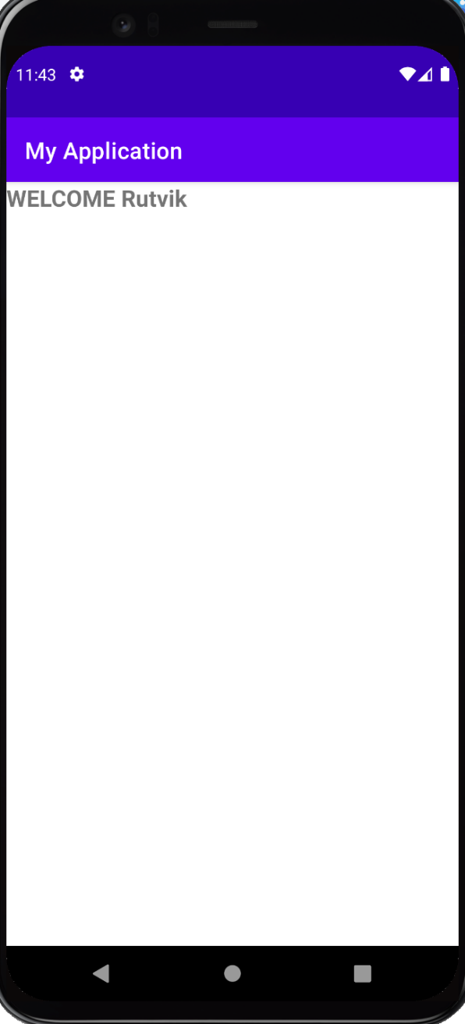

Task

Activity_main.xml

<?xml version="1.0" encoding="utf-8"?>  
<LinearLayout xmlns:android="http://schemas.android.com/apk/res/android"  
 xmlns:app="http://schemas.android.com/apk/res-auto"  
 xmlns:tools="http://schemas.android.com/tools"  
 android:layout_width="match_parent"  
 android:layout_height="match_parent"  
 tools:context=".MainActivity"  
 android:orientation="vertical"  
 tools:ignore="ExtraText">  
  
 <EditText  
 android:layout_width="match_parent"  
 android:layout_height="wrap_content"  
 android:id="@+id/etid"  
 android:hint="Enter Your ID"  
 android:layout_marginTop="150dp"  
 android:textSize="20dp"  
 android:gravity="center"/>  
  
 <GridLayout  
 android:layout_width="wrap_content"  
 android:layout_height="wrap_content"  
 android:layout_marginLeft="90dp"  
 android:layout_marginTop="20dp">  
  
 <RadioGroup  
 android:layout_width="match_parent"  
 android:layout_height="wrap_content"  
 android:id="@+id/rg"  
 android:orientation="horizontal"  
 android:gravity="center">  
  
 <RadioButton  
 android:layout_width="wrap_content"  
 android:layout_height="wrap_content"  
 android:id="@+id/rgm"  
 android:hint="Male"  
 android:textSize="20dp"  
 android:layout_marginRight="10dp"  
 android:checked="true"  
 android:text="Male"/>  
  
 <RadioButton  
 android:id="@+id/rgf"  
 android:layout_width="wrap_content"  
 android:layout_height="wrap_content"  
 android:layout_marginRight="10dp"  
 android:checked="true"  
 android:text="Female"  
 android:textSize="20dp"/>  
  
 </RadioGroup>  
 </GridLayout>  
  
 <EditText  
 android:layout_width="match_parent"  
 android:layout_height="wrap_content"  
 android:id="@+id/etemail"  
 android:hint="Enter Your Email"  
 android:layout_marginTop="20dp"  
 android:textSize="20dp"  
 android:gravity="center"/>  
  
 <EditText  
 android:layout_width="match_parent"  
 android:layout_height="wrap_content"  
 android:id="@+id/etm"  
 android:hint="Enter Your Mobile"  
 android:layout_marginTop="20dp"  
 android:textSize="20dp"  
 android:gravity="center"/>  
  
 <EditText  
 android:layout_width="match_parent"  
 android:layout_height="wrap_content"  
 android:id="@+id/etpassword"  
 android:hint="Enter Your password"  
 android:layout_marginTop="20dp"  
 android:textSize="20dp"  
 android:gravity="center"  
 android:inputType="textPassword" />  
  
 <EditText  
 android:layout_width="match_parent"  
 android:layout_height="wrap_content"  
 android:id="@+id/ethobbies"  
 android:hint="Enter Your Hobbies"  
 android:layout_marginTop="20dp"  
 android:textSize="20dp"  
 android:gravity="center"/>  
  
 <Button  
 android:layout_width="match_parent"  
 android:layout_height="wrap_content"  
 android:id="@+id/btsubmit"  
 android:hint="SUBMIT"  
 android:gravity="center"  
 android:layout_marginTop="20dp"/>  
</LinearLayout>

MainActivity.java

package com.example.first;  
  
import androidx.appcompat.app.AppCompatActivity;  
import android.content.Intent;  
import android.os.Bundle;  
import android.view.View;  
import android.widget.Button;  
import android.widget.EditText;  
import android.widget.RadioButton;  
import android.widget.RadioGroup;  
  
public class MainActivity extends AppCompatActivity {  
  
 EditText etid;  
 RadioGroup rg;  
 EditText etemail;  
 EditText etm;  
 EditText etpassword;  
 EditText ethobbies;  
 Button btsubmit;  
 RadioButton rgm;  
 RadioButton rgf;  
  
 @Override  
 protected void onCreate(Bundle savedInstanceState) {  
 super.onCreate(savedInstanceState);  
 setContentView(R.layout.*activity_main*);  
 etid = (EditText) findViewById(R.id.*etid*);  
 rg = (RadioGroup) findViewById(R.id.*rg*);  
 etemail = (EditText) findViewById(R.id.*etemail*);  
 etm = (EditText) findViewById(R.id.*etm*);  
 etpassword = (EditText) findViewById(R.id.*etpassword*);  
 ethobbies = (EditText) findViewById(R.id.*ethobbies*);  
 rgm = (RadioButton) findViewById(R.id.*rgm*);  
 rgf = (RadioButton) findViewById(R.id.*rgf*);  
 btsubmit = (Button) findViewById(R.id.*btsubmit*);  
 btsubmit.setOnClickListener(new View.OnClickListener() {  
 @Override  
 public void onClick(View v) {  
 String idS = etid.getText().toString();  
 String emailS = etemail.getText().toString();  
 String mobileS = etm.getText().toString();  
 String passwordS = etpassword.getText().toString();  
 String hobbiesS = ethobbies.getText().toString();  
 String maleS = rgm.getText().toString();  
 String femaleS = rgf.getText().toString();  
  
 Intent intent = new Intent(MainActivity.this,ResultActivity.class);  
 intent.putExtra("NAME",idS);  
 intent.putExtra("MALE",maleS);  
 intent.putExtra("FEMALE",femaleS);  
 intent.putExtra("EMAIL",emailS);  
 intent.putExtra("MOBILE",mobileS);  
 intent.putExtra("PASSWORD",passwordS);  
 intent.putExtra("HOBBIES", hobbiesS);  
 startActivity(intent);  
 }  
 });  
 }  
}

activity_result.xml

<?xml version="1.0" encoding="utf-8"?>  
<LinearLayout xmlns:android="http://schemas.android.com/apk/res/android"  
 xmlns:app="http://schemas.android.com/apk/res-auto"  
 xmlns:tools="http://schemas.android.com/tools"  
 android:layout_width="match_parent"  
 android:layout_height="match_parent"  
 tools:context=".ResultActivity"  
 android:orientation="vertical">  
  
 <TextView  
 android:layout_width="match_parent"  
 android:layout_height="wrap_content"  
 android:id="@+id/tx1"  
 android:layout_marginTop="40dp"  
 android:gravity="left"  
 android:textSize="40dp"  
 android:layout_gravity="center"/>  
  
 <TextView  
 android:layout_width="match_parent"  
 android:layout_height="wrap_content"  
 android:id="@+id/tx2"  
 android:layout_marginTop="40dp"  
 android:gravity="left"  
 android:textSize="40dp"  
 android:layout_gravity="center"/>  
  
 <TextView  
 android:layout_width="match_parent"  
 android:layout_height="wrap_content"  
 android:id="@+id/tx3"  
 android:layout_marginTop="40dp"  
 android:gravity="left"  
 android:textSize="40dp"  
 android:layout_gravity="center" />  
  
 <TextView  
 android:layout_width="match_parent"  
 android:layout_height="wrap_content"  
 android:id="@+id/tx4"  
 android:layout_marginTop="40dp"  
 android:gravity="left"  
 android:layout_gravity="center"  
 android:textSize="40dp"/>  
  
 <TextView  
 android:layout_width="match_parent"  
 android:layout_height="wrap_content"  
 android:id="@+id/tx5"  
 android:layout_marginTop="40dp"  
 android:gravity="center"  
 android:textSize="40dp"/>  
  
 <TextView  
 android:layout_width="match_parent"  
 android:layout_height="wrap_content"  
 android:id="@+id/tx6"  
 android:layout_marginTop="40dp"  
 android:gravity="center"  
 android:textSize="40dp"/>  
  
 <TextView  
 android:layout_width="match_parent"  
 android:layout_height="wrap_content"  
 android:id="@+id/tx7"  
 android:layout_marginTop="40dp"  
 android:gravity="center"  
 android:textSize="40dp"/>

</LinearLayout>

Output:

